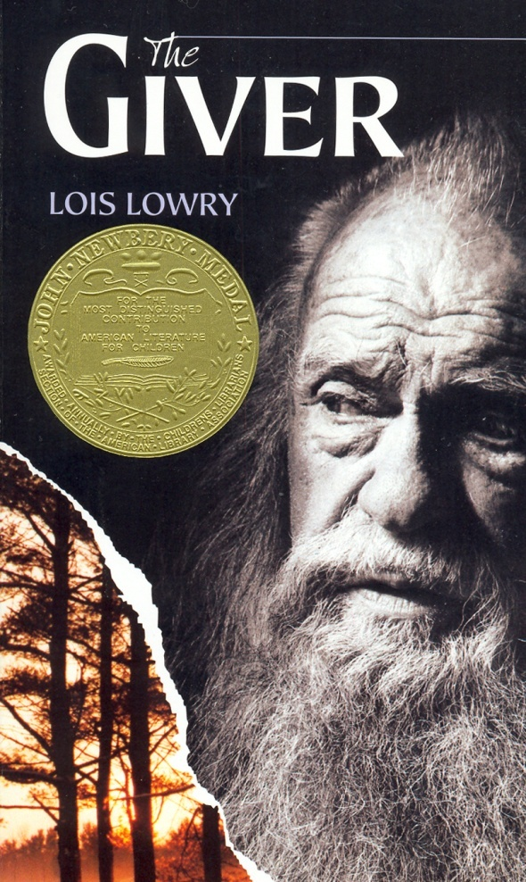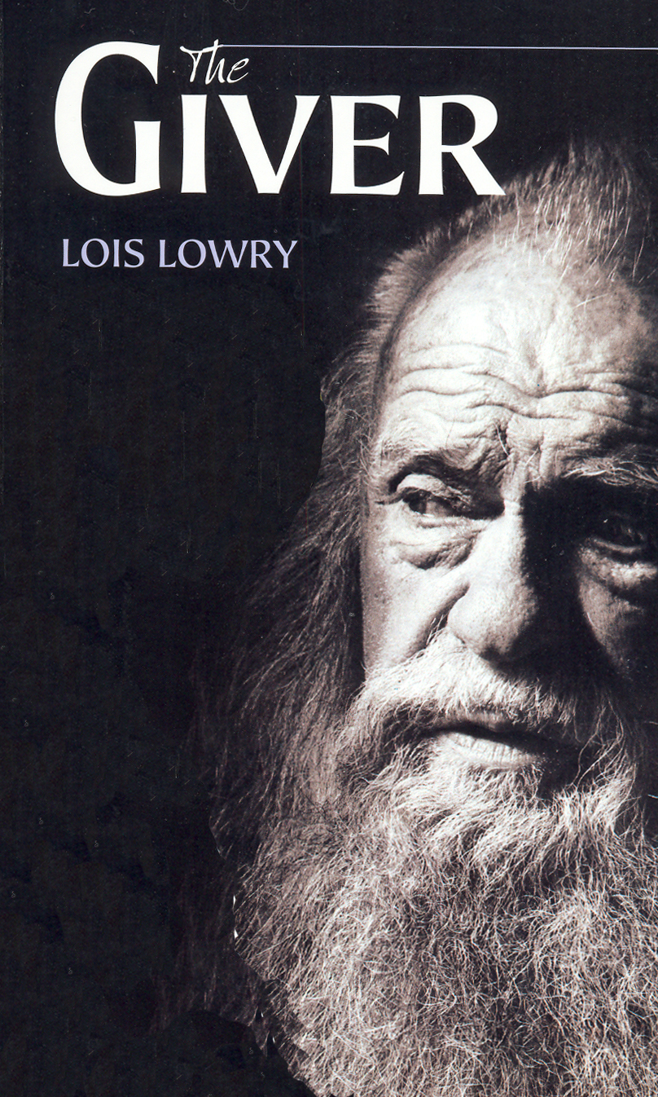

Join a Book Discussion of

*The Giver*

by Lois Lowry

Friday, April 17

12:00 – 1:00

2nd Floor of the Library

Students, faculty, staff and the public are welcome!