

Image credit:

*Burning the midnight oil* by Alexis Birkill  


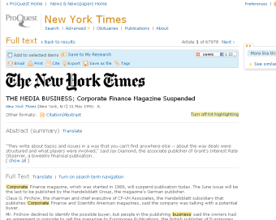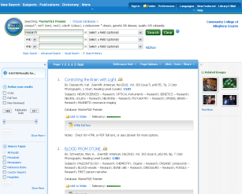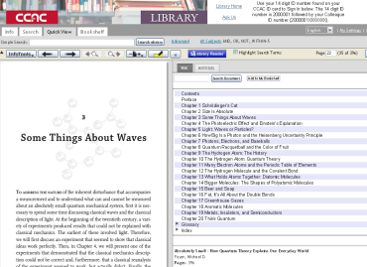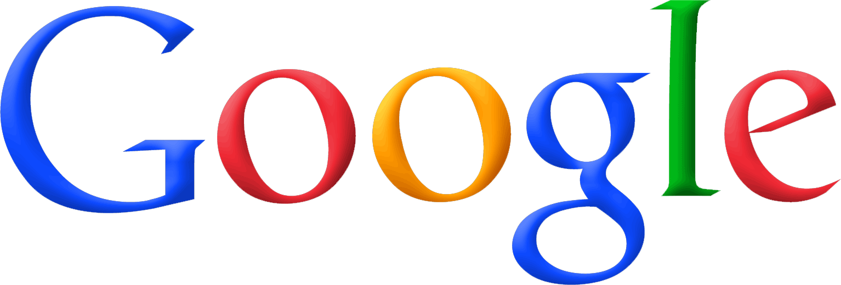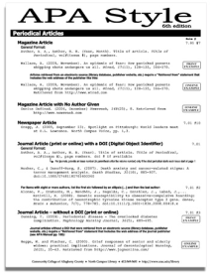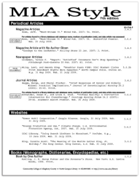

Citations

Article databases

Topics:

Library 101 is a 1 credit CCAC course designed to help you think about, find, and use information effectively.

Registration for Fall 2011 is open. Take one:

Library research has changed.

Are you up-to-date?

Ebooks

And more…